Name Quang Huynh
Properties of Matter Unit
Test Success

Here’s what you need to be successful on your next unit test on Matter:

- Know the basic meaning of all of the properties of matter that we used in your superhero project. Use your notes page 2.

Idea: Create a chart that includes the ones that you don’t know.

- Know all the basic characteristics of matter. Including the differences between solids, liquids and gases.
Be sure to include how they differ in:
- Motion of particles
- Position or arrangement of particles
- Volume and shape
- Amount of energy
Idea: make a poster showing diagrams of the 3 basic states of matter and their molecules. Add arrows in between each state of matter that show changes of state

- Know the following terms about changes of state:
melting freezing boiling
condensation sublimation vaporization
evaporation melting point boiling point

Idea: Complete the chart below for each state of matter.

Phase | Definite Shape (Y/N) | Definite Volume (Y/N) | Amount of Energy  (high, medium, low) | Position of Molecules (DENSITY)
Solid | Y | Y | low | packed
Liquid | N | Y | medium | less packed
Gas | N | N | high | very spread out
Plasma | N | Y/N | high | very spread out

- Know the difference between physical and chemical properties and changes:

Idea: label each of these as physical or chemical.
density physical boiling point physical
color physical reactivity with acids chemical
flammability chemical ability to rust chemical
malleability physical freezing point physical
solubility physical mass physical

heating water physical melting wax both
breaking your pencil physical scrambling an egg chemical
cooking an egg both water evaporating physical
Alka-Seltzer in water chemical digestion chemical
cutting your hair physical growth physical

- Know how to make and read a phase change diagram (graph) that shows the changes in water being heated starting as a solid and ending as a gas.
Idea: Make a change of state graph, be sure to include and label:
  - Solid, liquid, gas
  - Phase changes
  - What happens to the temperature at each letter as energy is being added or taken away?

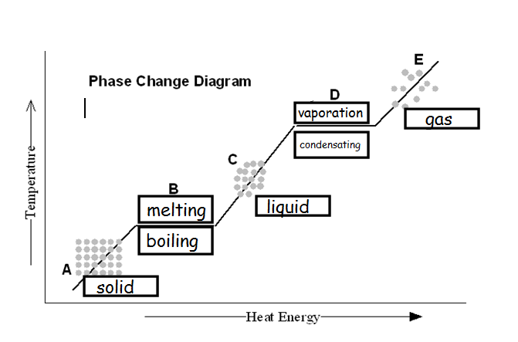
So, for boiling and melting, no temperature is changed. For the liquid phase, the temperature does in fact change. For condensation and vaporation, the temperature does not change, and for the gas phase, it does indeed change in temperature. Same for the solid phase. The solid phase’s temperature does change when energy is being taken or added.

